**Assignment # 5**

**Programming fundamentals**

**4th December, 2020 11:59pm**

**Weightage 5.**

**Note.**

* **Please avoid plagiarism.**
* **Contact me on email in case of any query.**
* **No late submissions would be accepted.**
* **Submit assignment on google classroom and note google classroom also checks plagiarism, so be careful.**
* **Only 25 to 30% plagiarism is acceptable.**

Q1: The picture mentioned below shows how pooling is performed on a matrix. You need to implement this. Input matrix size, values and size of pooling should be asked from user. For your convenience you may limit the size of matrix and pooling filter to be square.

**Note: Usage of Pointers is must, Use structures for matrix and pooling filter. The structure must have following properties.**

* Number of rows
* Number of cols
* Matrix[][] itself.

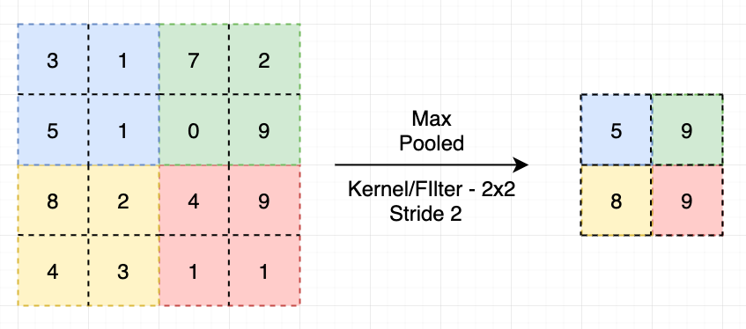

Q2. Use of pointers is must here. Calculate R (Pearson coefficient of correlation) which is mentioned below:

**Hint: Follow this link for complete understanding of the formula**

https://www.socscistatistics.com/tests/pearson/default2.aspx

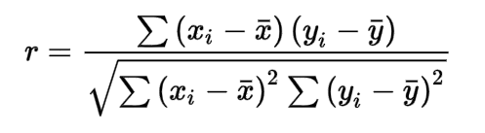

The values of x and y are mentioned below:

|  |  |
| --- | --- |
| X | Y |
| 1 | 2 |
| 3 | 4 |
| 5 | 6 |
| 7 | 8 |
| 9 | 10 |
| 11 | 12 |
| 12 | 13 |
| 14 | 15 |
| 16 | 17 |

Q3: Use of pointers is must. Calculate the Euclidian distance of the data mentioned below. The formula of Euclidian distance is mentioned below:

**Hint: Use this link for help:**

https://www.easycalculation.com/euclidean-distance-calculator.php

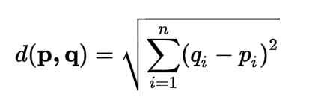

|  |  |
| --- | --- |
| P | Q |
| 1 | 2 |
| 3 | 4 |
| 5 | 6 |
| 7 | 8 |
| 9 | 10 |
| 11 | 12 |
| 12 | 13 |
| 14 | 15 |
| 16 | 17 |

Q4. Calculate the standard deviation of the data which is provided below:

10, 12, 23, 23, 16, 23, 21, 16

**Hint: You can take help from the link provided below:**

https://www.calculator.net/standard-deviation-calculator.html

